Practical - 12

Practical Title: Event Management CRUD with Poster Upload and File Validation

Develop event management functionality for admin users. Admin can add, view, update, delete, and upload event posters with file type and file size validation

Theory

Answers to key questions
1. Are add, update, and delete functionalities implemented correctly?
Yes. Admin users can add new events, update existing event details, and delete events using PHP and MySQLi.
2. Is the UI linked with the database correctly?
Yes. PHP retrieves event records from MySQL and displays them on the event management page.
3. Are poster uploads validated for type and size?
Yes. The server checks the uploaded file's MIME type and size before accepting it.
4. Are success and failure messages displayed?
Yes. The system displays messages when an event is successfully saved, updated, deleted, or when an operation fails.

Implementation/ Output/Result
- Created an event management interface for administrators.
- Connected PHP to MySQL using MySQLi.
- Implemented event insertion, viewing, updating, and deletion.
- Added poster upload functionality.
- Validated poster file type and maximum size on the server.
- Generated unique filenames for uploaded posters.
- Displayed success and error messages.
- Restricted event management to authorized admin users.

Output(ScreenShots):
Admin DashBoard(Only admin can access this):
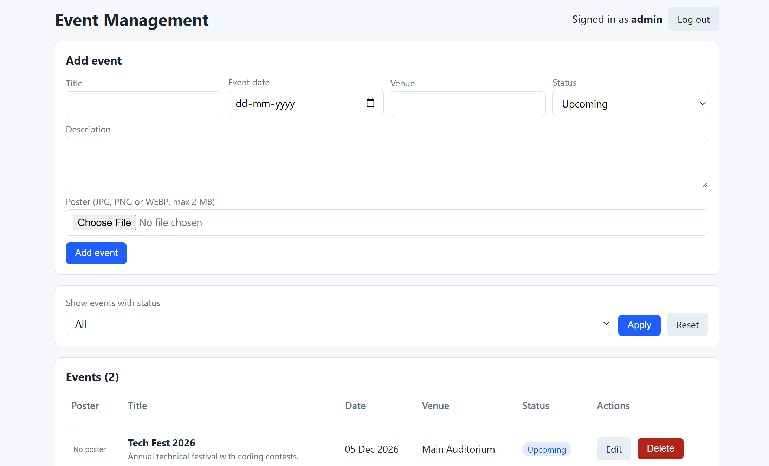

Event Add:
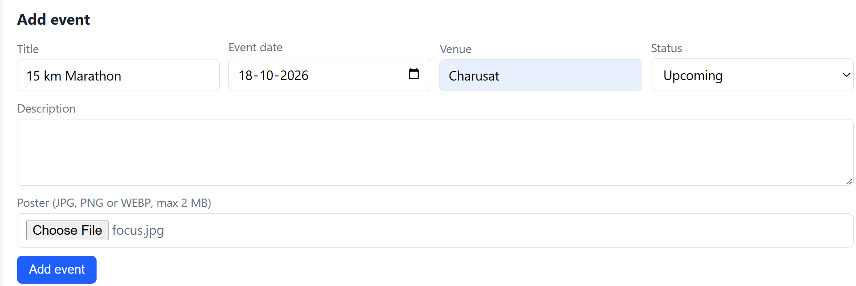

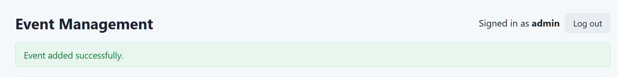

You can see the event is being added:


You can Filter Events by their status(Upcoming,Ongoing,Completed or Cancelled):
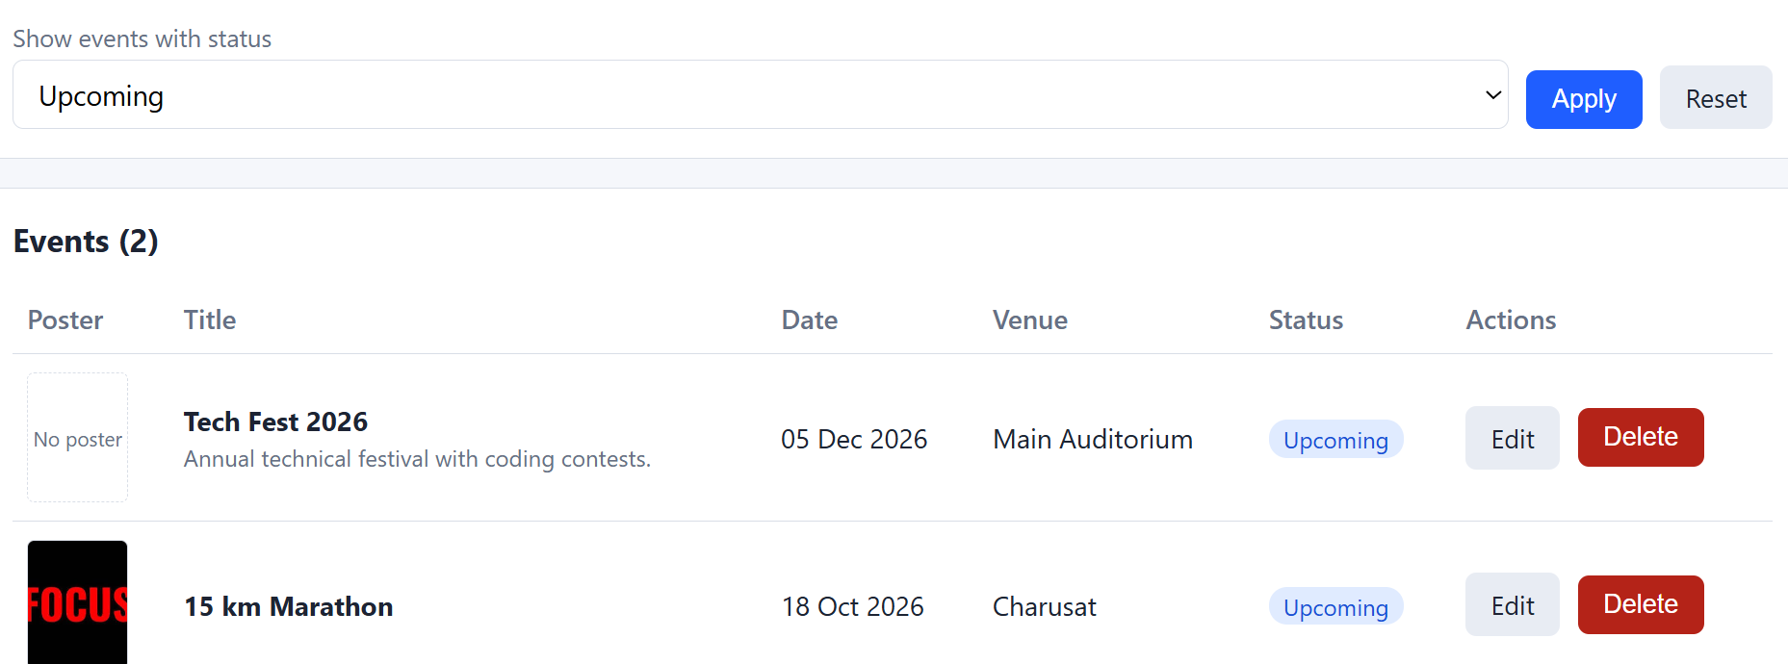

You can Delete the Event:
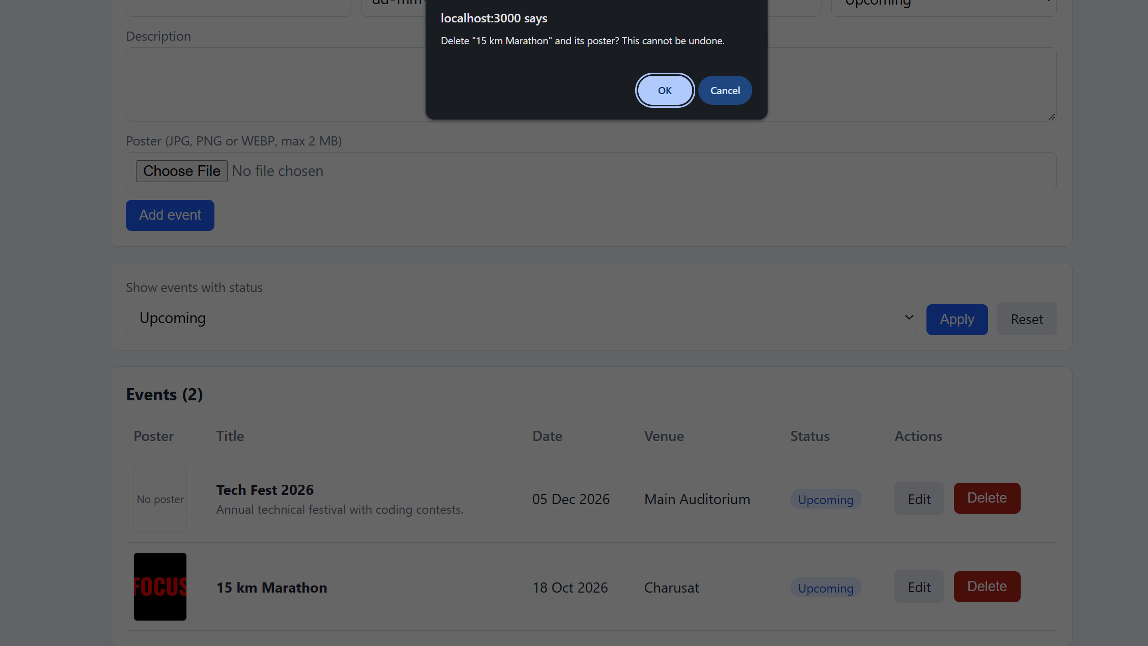

GitHub Repository Link:
https://github.com/HimeshMale/Student-Hub-Portal

Learning Outcomes:

Learned to develop an event management CRUD module with validated file uploads and database connectivity.

Faculty Remarks:

